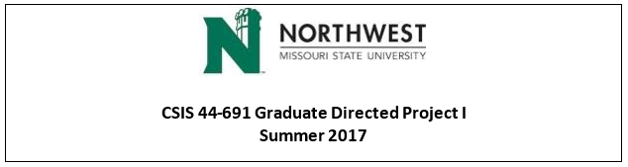

**Client name:** Dr. Michael Oudshoorn **Instructor:** Dr. Michael Oudshoorn

**Team Logo:**



**Team Members** **and Respective responsibilities**

|  |  |  |  |  |
| --- | --- | --- | --- | --- |
| Sl No. | Name | Role | Email | Contact |
| 1 | Sirisha Vanamali | Primary Contact | [S528176@nwmissouri.edu](mailto:S528176@nwmissouri.edu) | 816-572-0595 |
| 2 | Rohith Babu Sadhu | Client Management | [S528171@nwmissouri.edu](mailto:S528171@nwmissouri.edu) | 660-528-0926 |
| 3 | Sri Sai Ram Kumar Mamidala | Data management | [S528148@nwmissouri.edu](mailto:S528148@nwmissouri.edu) | 704-699-4107 |
| 4 | Vipul Reddy Madadi | Requirements Management | [S528144@nwmissouri.edu](mailto:S528144@nwmissouri.edu) | 660-528-0357 |
| 5 | Vamsi Devalla | Quality and Testing Management | [S528117@nwmissouri.edu](mailto:S528117@nwmissouri.edu) | 660-541-0439 |
| 6 | Subba Reddy Pothireddy | Issue Management | [S528168@nwmissouri.edu](mailto:S528168@nwmissouri.edu) | 660-528-0046 |
| 7 | Shankar Rao Vallapurapu | Communications and Documentation management | [S528175@nwmissouri.edu](mailto:S528175@nwmissouri.edu) | 660-528-0890 |

**Problem Statement:**

Vision: We want to develop a system which makes the life of an instructor easy in terms of tracking the attendance of a student with minimum effort.

Issue: Today, we are using different traditional ways which have certain limitations, ignoring them would make people easier to abuse them.

Method: We will be using the QR codes for tracking the attendance of the students.

The attendance tracking system that most Universities use is through a piece of paper. For classes, lab sessions, help sessions the student still has to sign on the attendance sheet. This method is not flexible as the risk of losing the attendance sheet is high and it also encourages unethical practices like forgery of signature. The new system that our University makes use of is a physical device to log attendance of students. This mechanism is also an age old process where the user runs his Magnetic Stripe ID card through the physical device and the device detects the unique ID associated with the magnetic strip and accordingly logs the attendance of the user. This solution needs a hardware device to be installed wherever necessary to mark attendance of users and it becomes an expensive affair to purchase these devices and get them installed. Also, with devices comes maintenance. To address the various problems that old mechanism pose, we propose you with a painless and a more user-oriented software application to make the attendance tracking hassle free and maintenance free. The proposed system requires no hardware and it’s completely a software based solution. This application addresses all the existing problems as it’s user-friendly, easy to use and has utmost authentication procedure. The client- application will generate a unique QR code for every class and the students should be able to scan the QR code and mark their attendance. There will be another QR code generated again after sometime during the class, according to the client’s choice of time interval and the user is supposed to scan it to confirm his/her presence inside the class. The details of the student and the class details along with the timestamp and the device ID are captured in the database. This will ensure data retention and the professor can analyze the data whenever and wherever possible.